Case 5-Asia-China-Shang-Zun-Bronze-1500 BCE
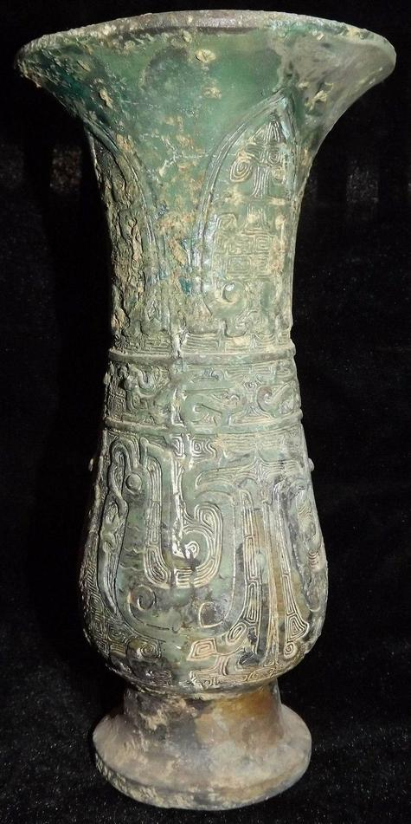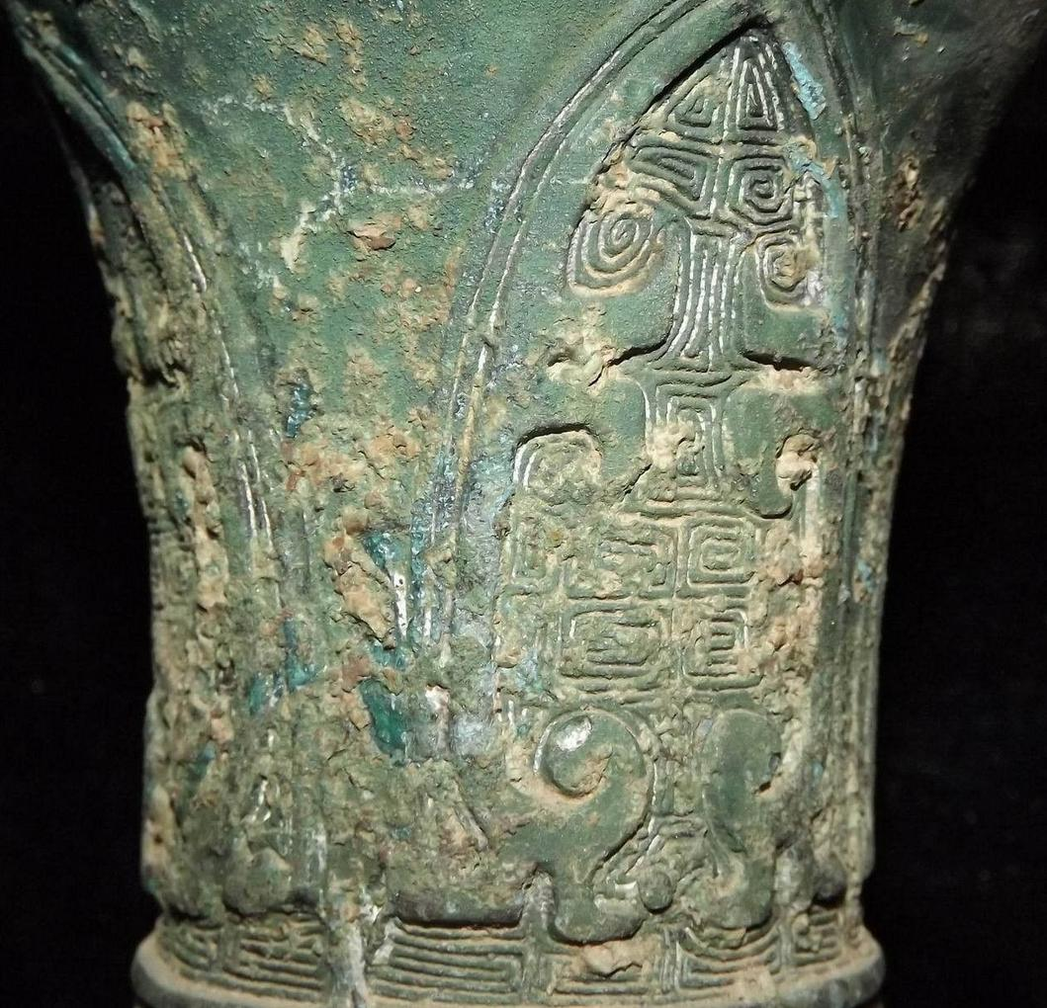
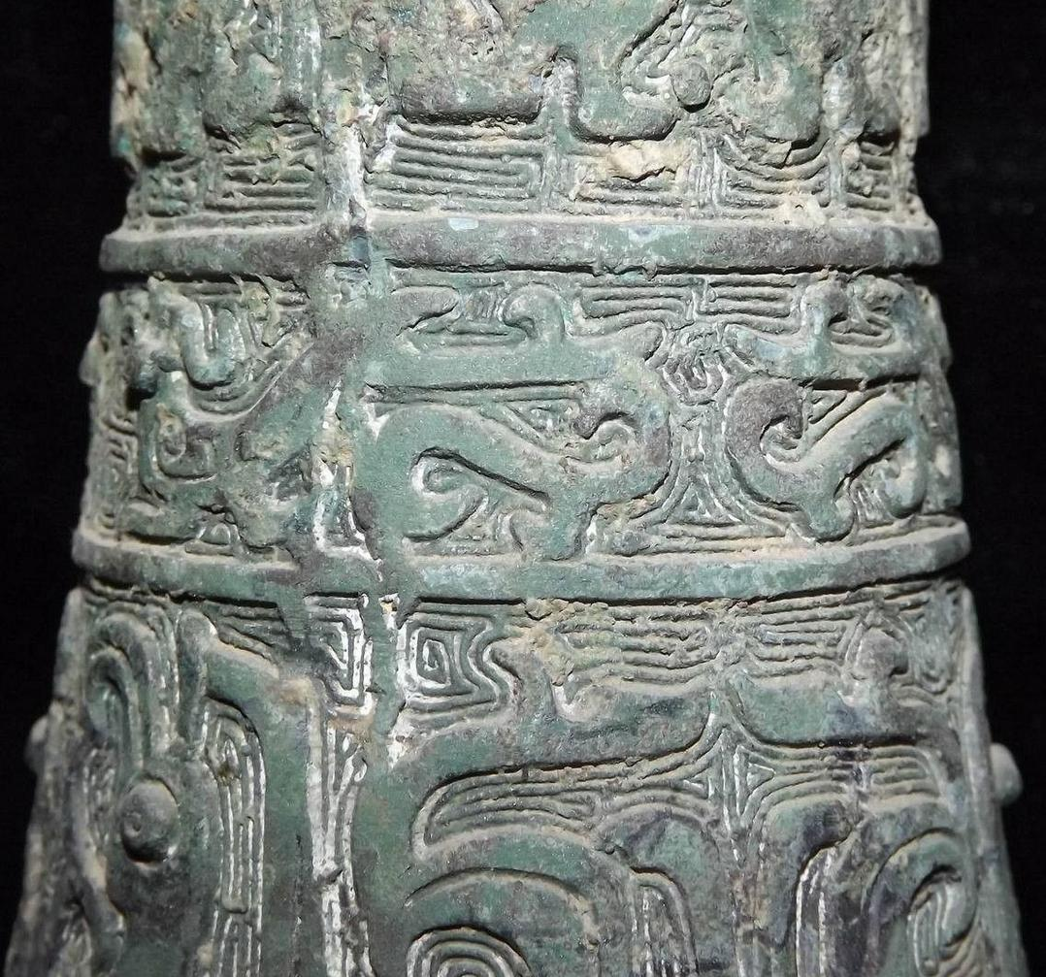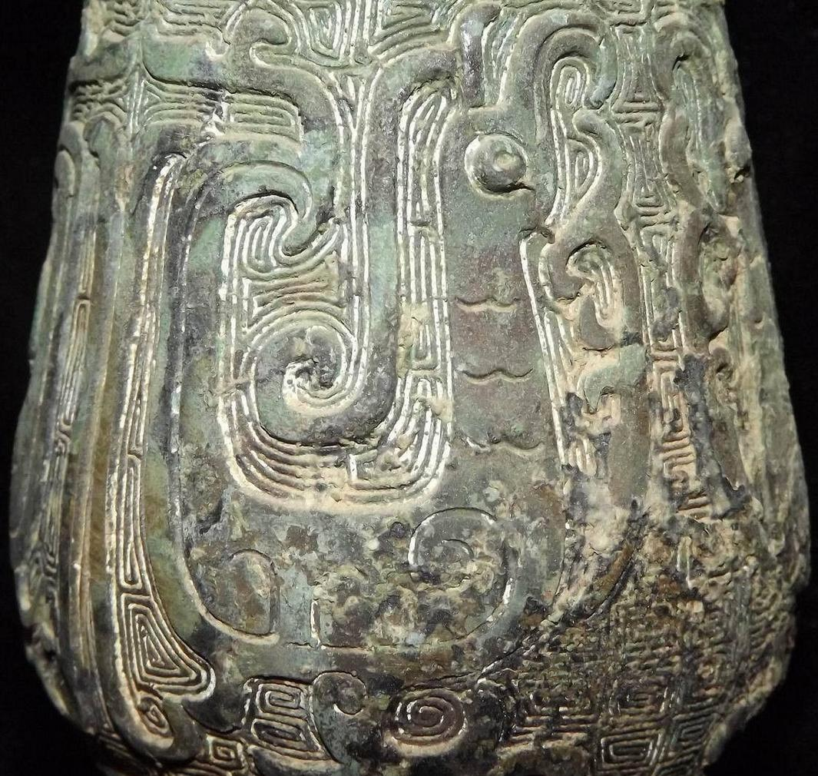
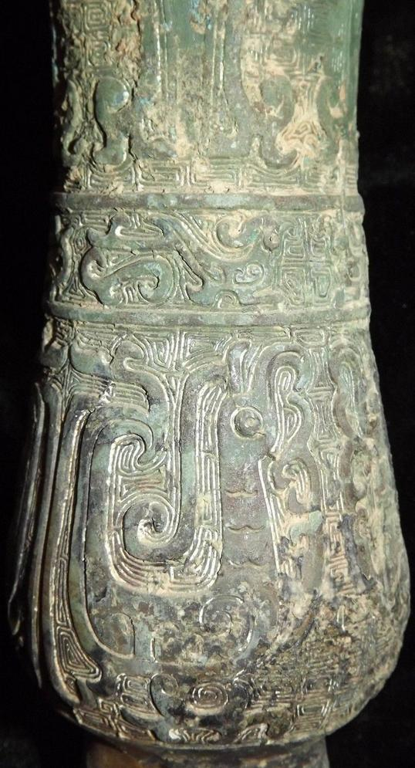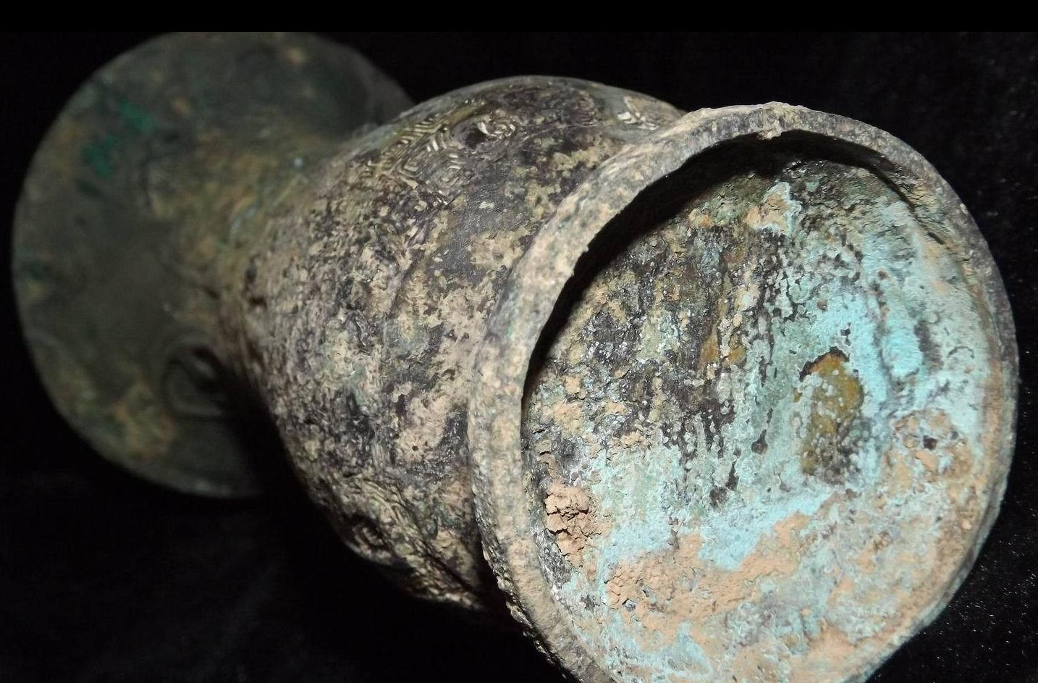

Case No.: 5
Accession Number:
Formal Label:
Display Description:
'Zun' is a ritual wine vessel consisting of a jar with a widely flared lip supported on a tall footring. In the second half of the Shang the shouldered 'zun' was replaced by a taller columnar vessel based on the 'gu' and often designated as a cylindrical 'zun' (Rawson 1992).
LC Classification: NK7983.22
Date or Time Horizon: 1200 BCE
Geographical Area:
Map:
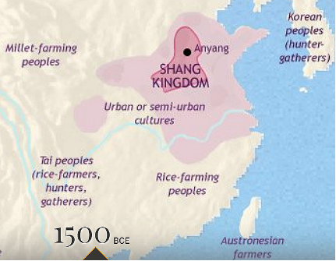
Map of Shang China, 1500 BCE after https://www.timemaps.com/history/china-1500bc/
GPS Coordinates:
Cultural Affiliation: Shang
Medium: bronze
Dimensions:
Weight:
Provenance:
Condition:
Discussion:
References:
Rawson, Jessica. 1992. The British Museum Book of Chinese Art. London: British Museum Press.
